* **why should we use Spring ?**
* Basically, Spring is a very popular framework , for building enterprise Java applications. When Spring first came out , it was initially a simpler, lightweight alternative to J2EE. They basically give you a large number of helper classes to make enterprise development easier.

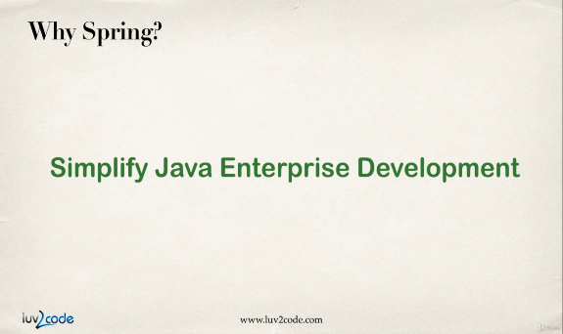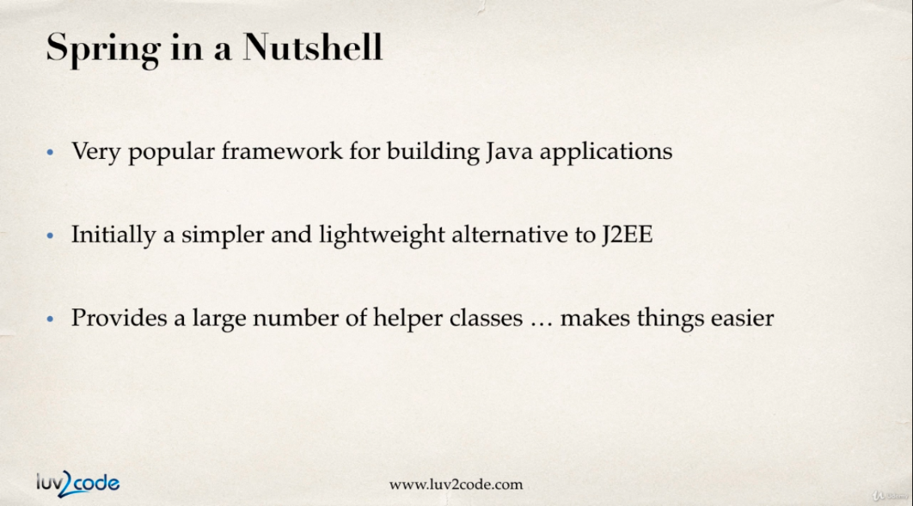

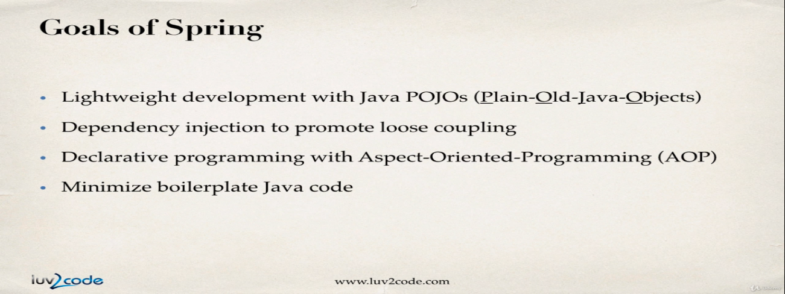

* **what about J2EE or Java EE ?**
* Java EE simplifies enterprise applications by defining and specifying a complete set of common standard services, such as naming, transaction management, concurrency, security, and database access. Java EE also defines a container model, which houses and manages instances of Java EE application components.
* **What is Java EE vs Spring ?**
* Java EE works with web-based and non-web-based structures, while Spring provides multiple structures covering microservices, cloud, serverless event drivers, and others.

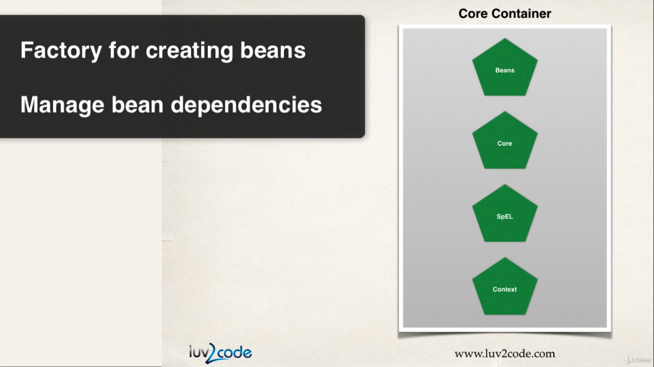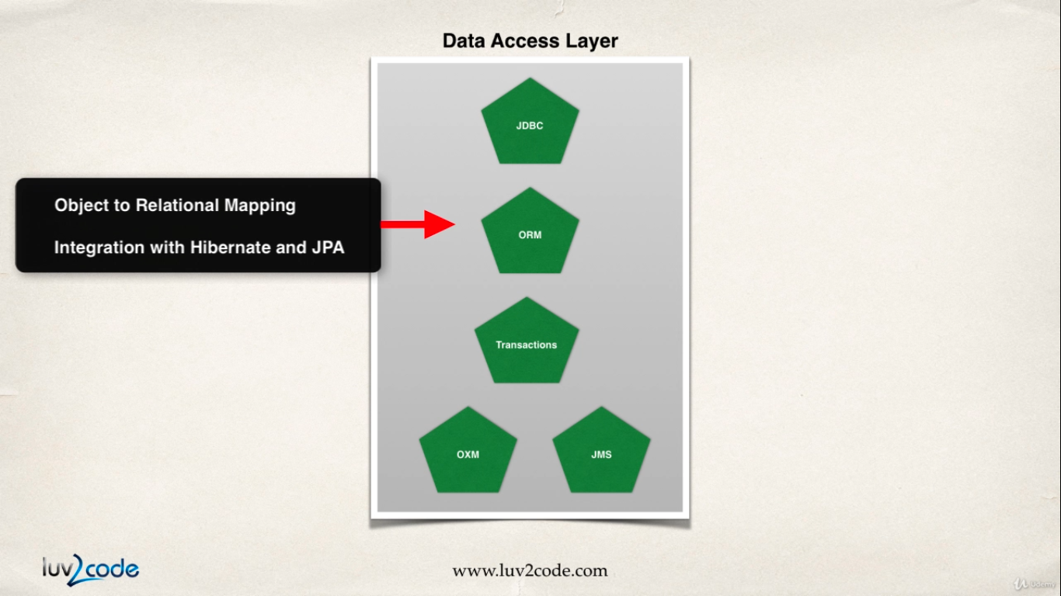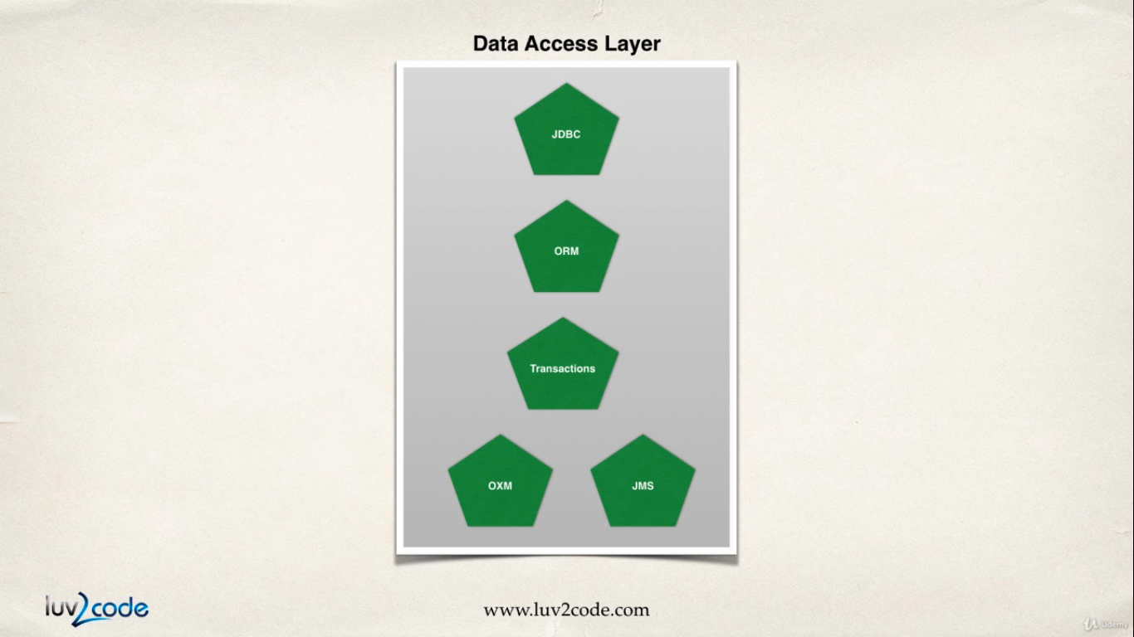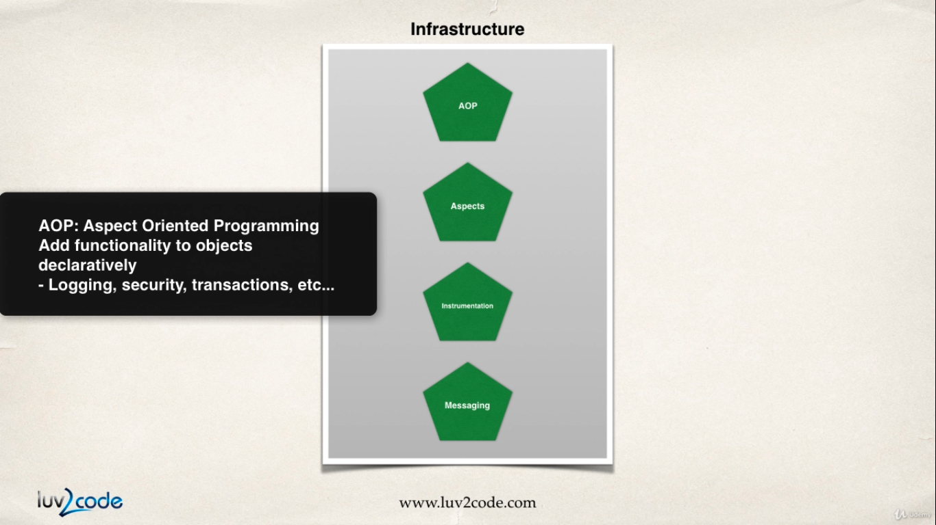

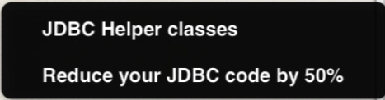

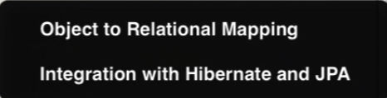

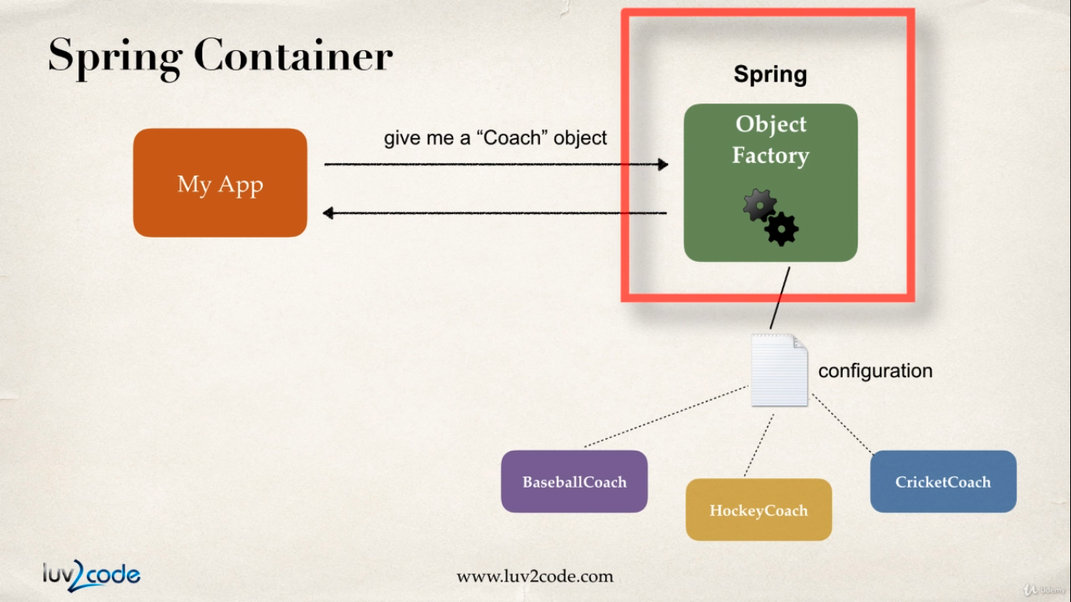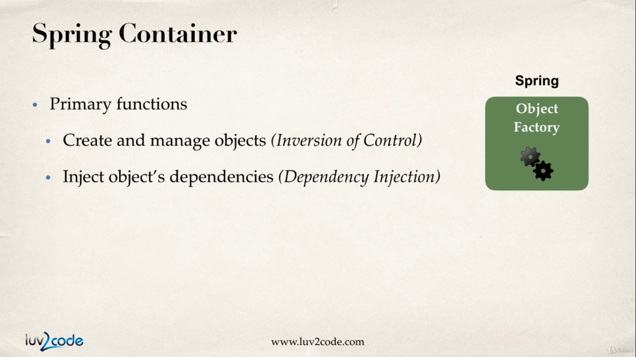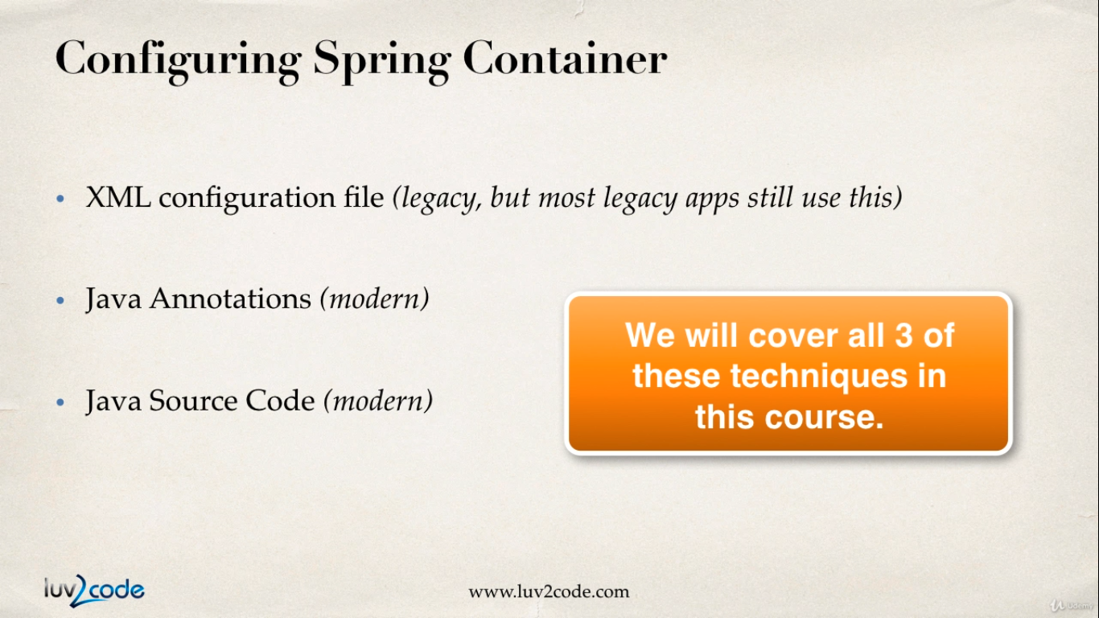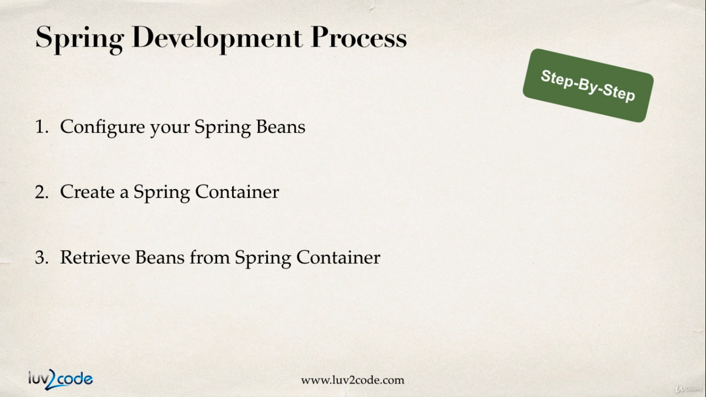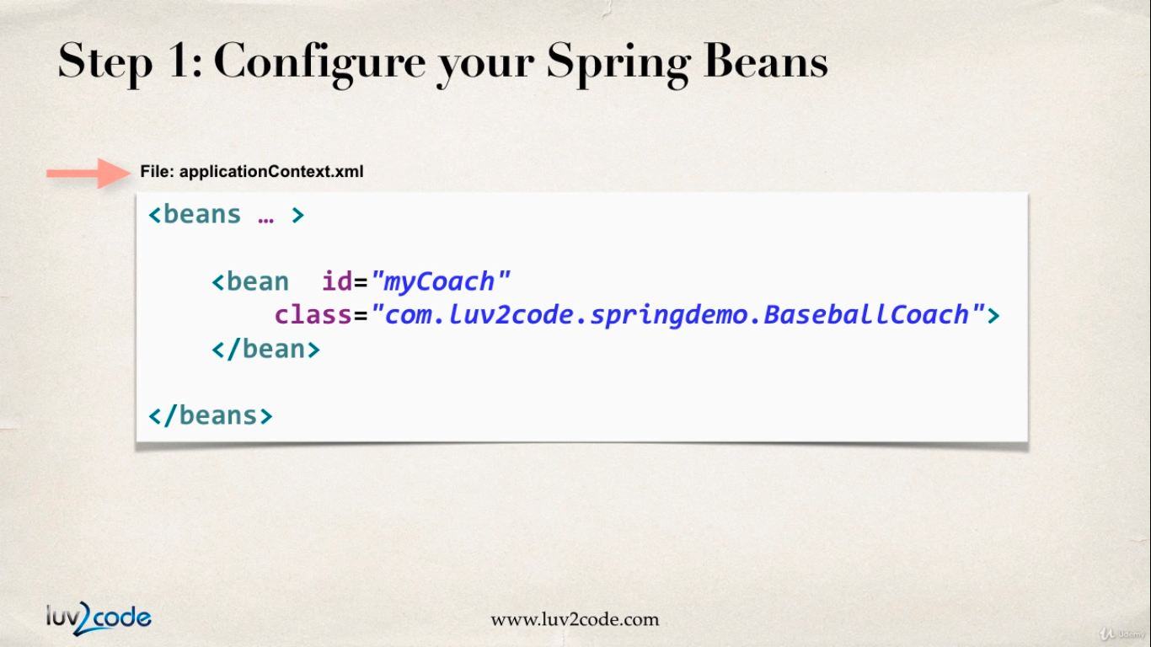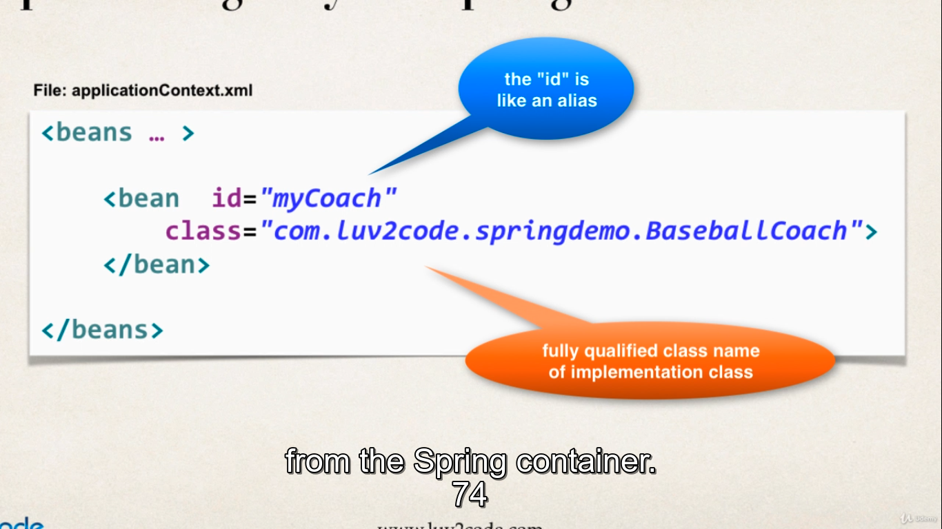  
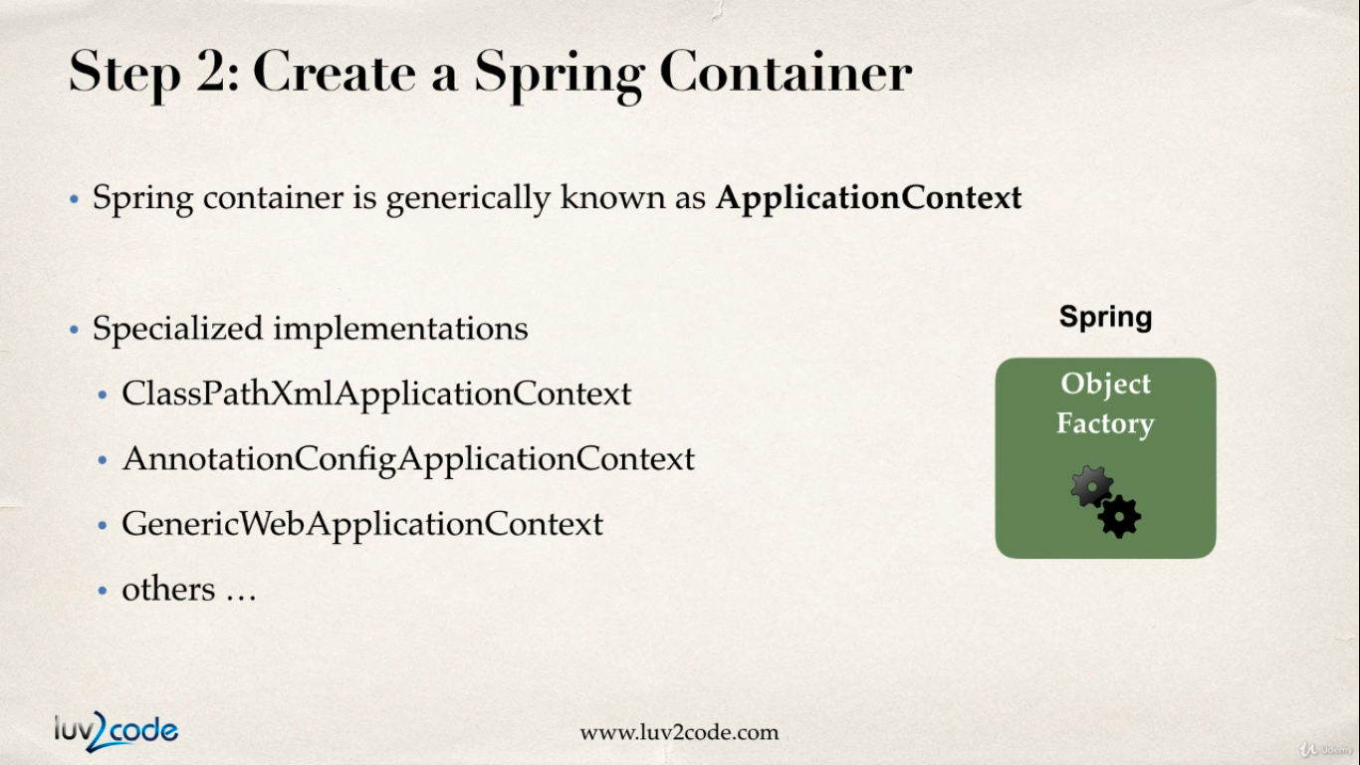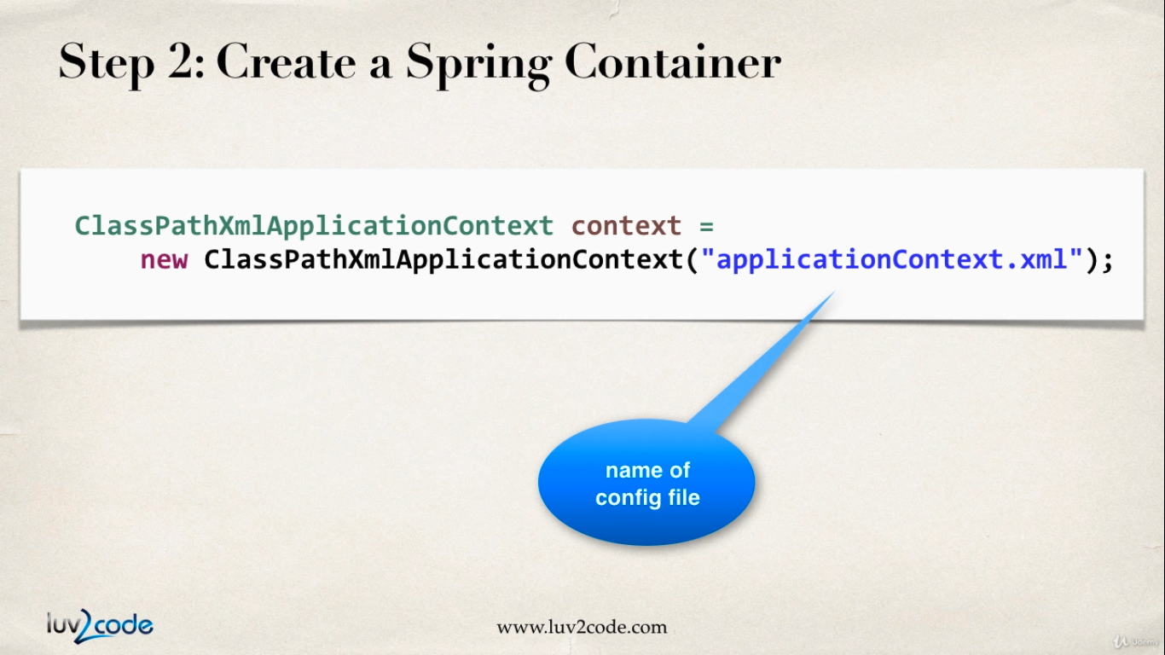

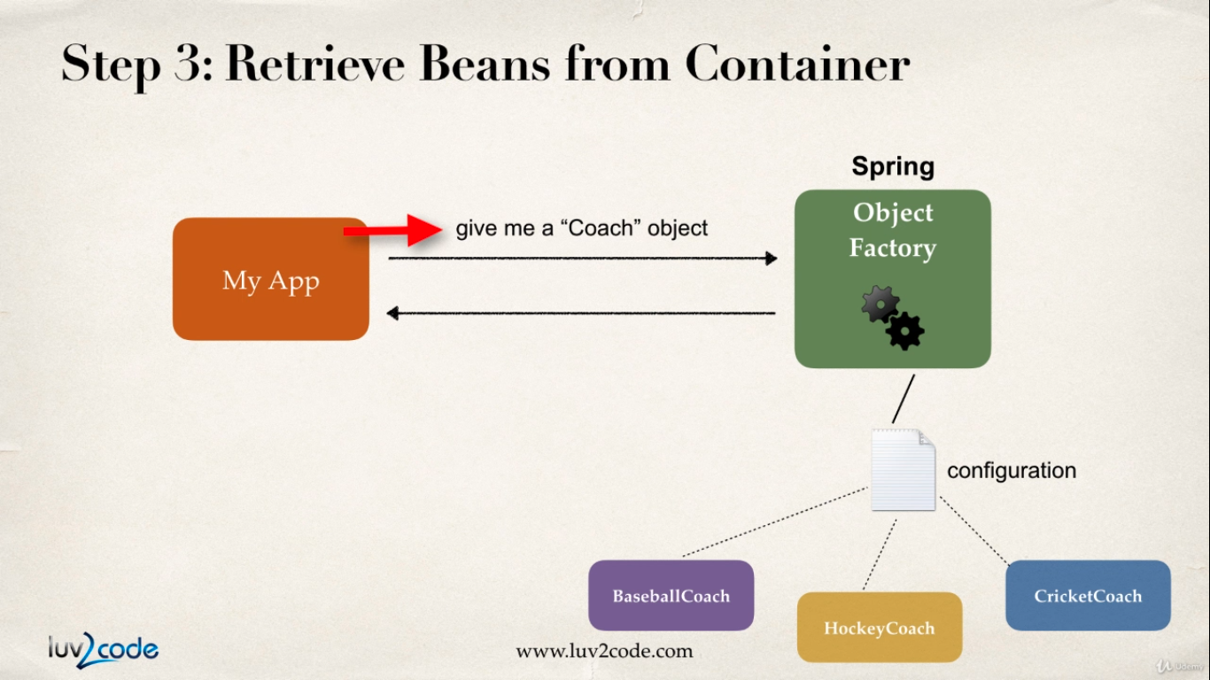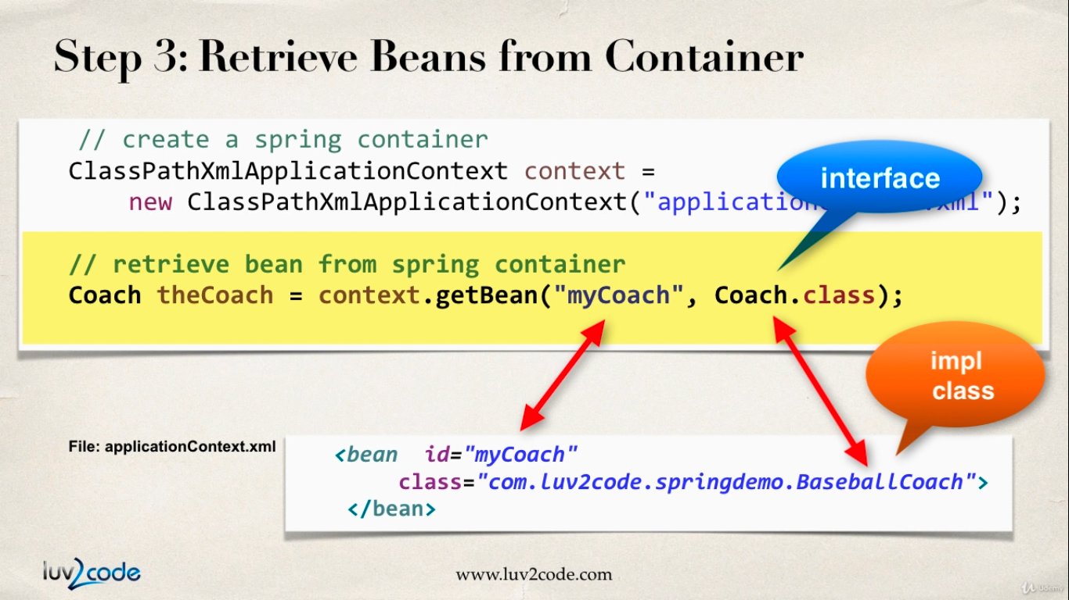

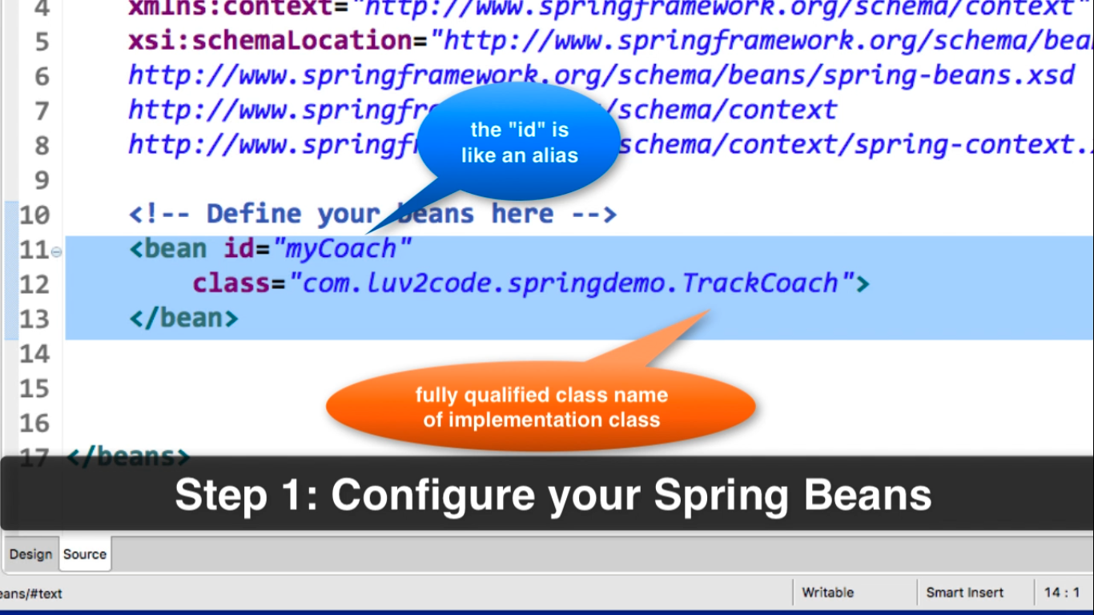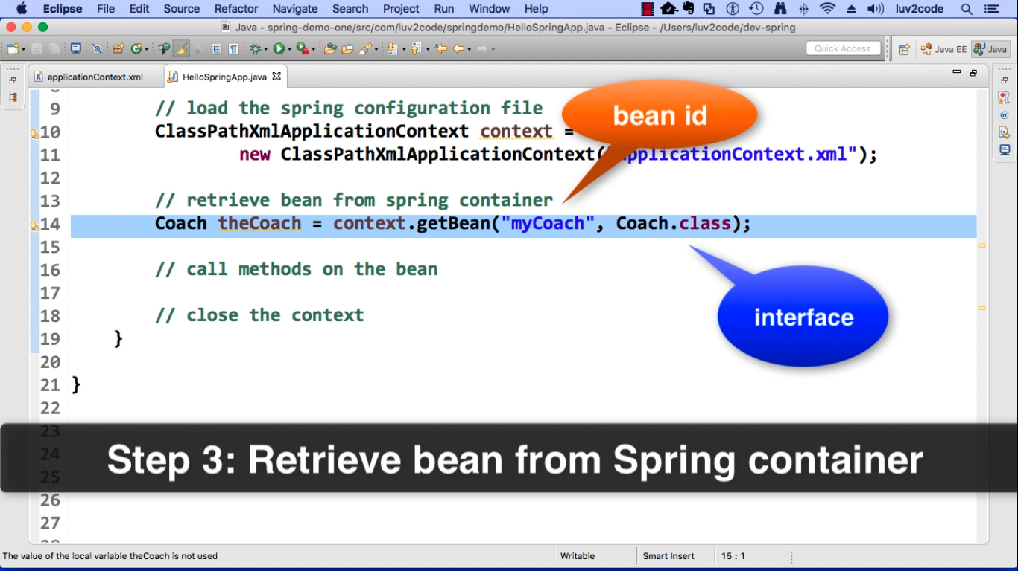

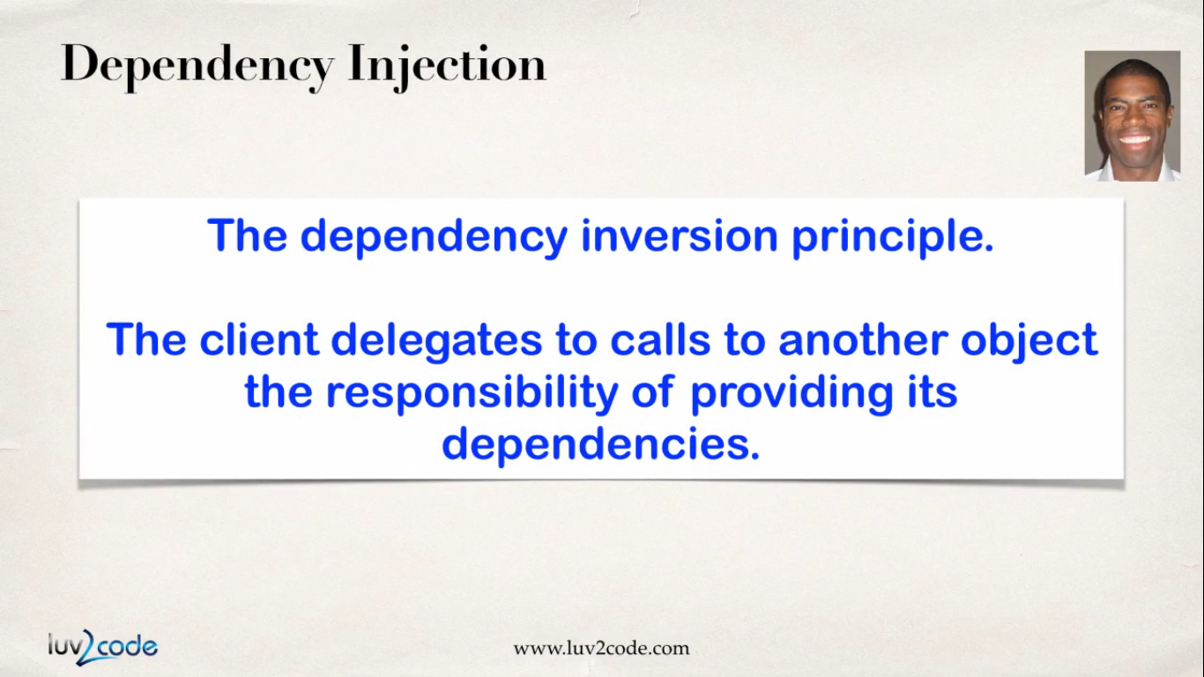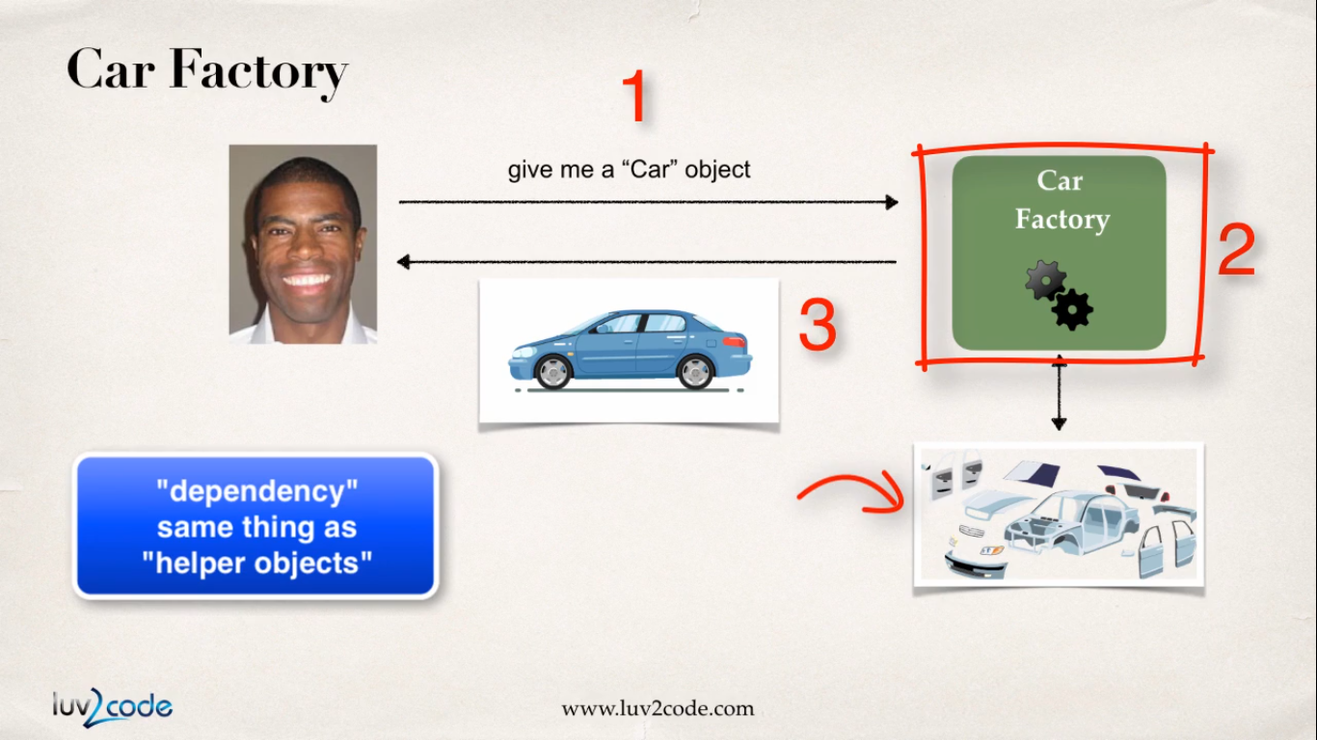

So, say for example, I'm going to buy a car and this car is built at the factory on demand. So, there's nothing in the car lot. You have to actually talk to the factory and put in a request and they'll build a car for you So, at the factory, you have all the different parts for the car. You have the car chassis, you have the engine, the tires, the seats, the electronics, the exhaust, and so on. And the mechanics or the assemblers there or the technicians, they'll actually aseemble the car for you and then deliver to you the final car. So, you don't have to actually build the car. The car's already built for you at the factory. So, they actually inject all of the dependencies for the car. So they inject the engine, they inject the tires, the seats and so on. So that's basically what you have here with dependency injection. So you simply outsource the construction and injection of your object to an external entity. In this case, that's the car factory.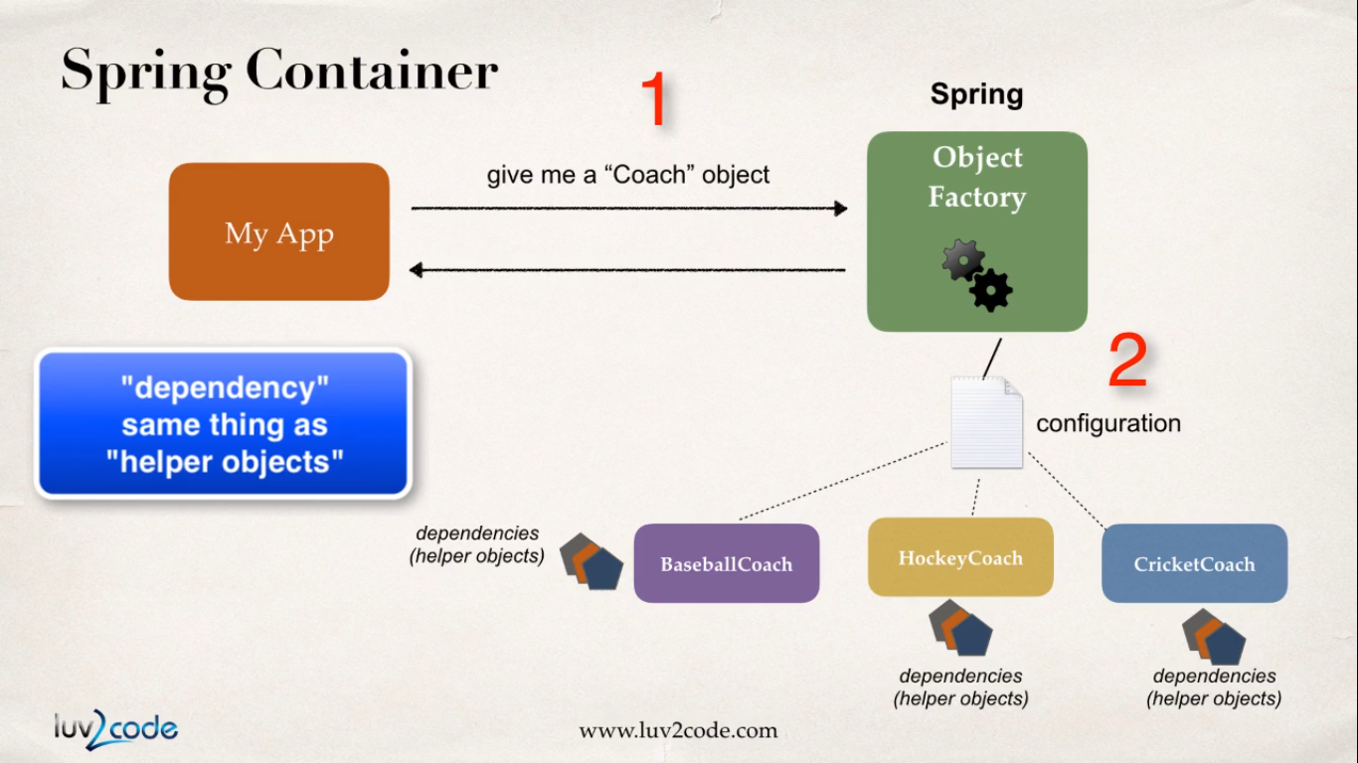

**How do this work in the Spring world ?**

* Well remember that Spring has am object factory, right ? So then, when you retrieve an object like a coach object, this coach object may have some addition dependencies. So these dependencies are really just helper objects, other objects that it needs to perform it's operation. So instead of you have to manually build the coach object and all of it's dependencies,
* the Spring framework of the Spring factory will actually do this work for you. So just like you get a car that's ready to drive, here you'll get an object that's ready to use. Alright, so that's Spring container.

